

PROJECT BASED LEARNING

COLLISION DETECTION SYSTEM



*COLLISION DETECTOR*

By TEAM

* + - * + Manav Nayyar (71)
        + Ketaki Nerkar (89)
        + Rohit Mehta (77)
        + Lipakshi Nagedeve(84)

## ACKNOWLEDGEMENTS

I have taken efforts in this project. However, it would not have been possible without the kind support and help of many individuals and organizations. I would like to extend my sincere thanks to all of them.

I am highly indebted to **Prof. GANESH WANI** for their guidance and constant supervision as well as for providing necessary information regarding the project & also for their support in completing the project.

I would like to express my gratitude towards my parents & **members of AISSMS IOIT** for their kind co-operation and encouragement which helped me in completion of this project.

My thanks and appreciations also go to my group members for their time and effort in developing the project and people who have willingly helped me out with their abilities.



#### Department of Engineering Sciences A MINI PROJECT REPORT ON COLLISION DETETCTION

**SUBMITTED BY**

|  |  |
| --- | --- |
|  |  |
|  |  |
| **MANAV NAYYAR** | **71** |
| **ROHIT MEHTA** | **77** |
| **KETAKI NERKAR** | **89** |
| **LIPAKSHI NAGDEVE** | **84** |
|  |  |
|  |  |
| STUDENT NAME | ERP ROLL NO. |



#### 2022 -2023



**Department of Engineering Sciences**

## CERTIFICATE

This is to certify that the project report on COLLISION DETECTION is Submitted by

|  |  |
| --- | --- |
| **MANAV NAYYAR**  **ROHIT MEHTA** | **71**  **77** |
| **KETAKI NERKAR** | **89** |
| **LIPAKSHI NAGEDEVE** | **84** |
| STUDENT NAME | ROLL NO. |

is a bonafide student of this institute and the work has been carried out by him/her under the supervision of Prof. Ganesh Waniand it is approved for the partial fulfillment of the Department of Artificial Intelligence and Data Science AISSMS IOIT.

#### (Prof. Ganesh Wani)

Guide Head,

Department of AI-DS Department of AI-DS

Place: Pune Date:

## ABSTRACT

Despite technical developments and improvements for vehicle safety, the incidence of collisions at urban and rural crossings has increased. Nearly a third of all recorded crashes, according to reports, take place in these locations. In light of this, a trustworthy, accurate ,a collision warning system that can warn drivers in advance. The majority of collision avoidance technologies under development today rely on vehicle-to-vehicle or inter-vehicle communication.

Such systems are vehicle-specific, limiting their applicability to vehicles possessing the necessary technologies.

This project involved the development and testing of an intersection collision warning (ICW) system that relied only on infrastructure connectivity. For the purpose of detecting and providing drivers with warning information, ICW uses wireless sensor networks (WSN).

The technology is installed in intersecting roadways and provides real-time collision prevention by keeping an eye on oncoming traffic and alerting drivers to the likelihood of an impending collision.

Autonomous and semi-autonomous vehicles use collision detection systems, a cutting-edge technology, to identify possible collisions and avoid them. This technology can be applied to improve pedestrian, passenger, and vehicle safety. Collision detection systems use a range of sensors and algorithms to spot potential collisions and provide the driver or autonomous system the information they need to react appropriately. The algorithms use this information to determine the relative speed of the cars after the sensors have detected items in the surrounding area. Following that, the system determines the likelihood of an accident and alerts the driver or the autonomous system. In order to prevent a collision, the system is also capable of evasive action.

## TABLE OF CONTENTS

|  |  |  |
| --- | --- | --- |
| **SR. NO.** | **TITLE** | **PAGE NO.** |
| 1 | Problem statement | 7 |
| 2 | Objective | 7 |
| 3 | Introduction | 9 |
| 4 | Existing System | 10 |
| 5 | Proposed Methods | 13 |
| 6 | System Architecture | 13 |
| 7 | Ultrasonic Detection | 16 |
| 8 | Obstacle detection | 17 |
| 9 | Alerting System, | 18 |
| 10 | Source Code | 19 |
| 11 | Components | 22 |
| 12 | Application | 25 |
| 13 | Conclusion | 26 |
| 14 | References | 27 |

**PROBLEM STATEMENT**

The incidence of road accidents has increased as technology and motor vehicle manufacture have advanced. Because proper emergency facilities are not available, the survival rate following an accident is extremely low. Our concept would assist in detecting an accident and determining its location, which would then be communicated to the rescue team and the rider’s emergency contacts.

**OBJECTIVES AND SCOPE**

The main objective of this project is to prevent casualties which happen due to lack of

medical assistance in time. Certainly, if the accident happens due to other cases, the used

electronic devices will be able to provide the spontaneous message and exact location to

police and ambulance in order to recover victims. Avoiding casualties caused by road

accidents is the main goal of this paper, with the help of Accelerometer and GPS present in

the mobile phones. Based on the data collected from these sensors, which are present in most

mobile phones, the location of the accident is sent at the same time of the accident to the

friends and relatives which the user allowed and stored, and also to the rescue and emergency

services.

## CONTRIBUTIONS

|  |  |
| --- | --- |
| Lipakshi Nagdeve | PowerPoint presentation and Model |
| Rohit Mehta | Model and report |
| Manav Nayyar | Informative Website and Model |
| Ketaki Nerkar | Model Designing and PowerPoint presentation |

8

## INTRODUCTION

A report on Road Accidents in India by the Indian government stated that nearly 5lakh accidents have occurred and 1.5 lakh people nearly have been passed away in road accidents and leaving about 5 lakh people injured. Alcohol was found to result to 6755 deaths annually, which are more than 18 deaths daily across the country. A study has found that vision, braking behavior and vigilance are affected greatly even with low consumption of alcohol. The methodology was developed by keeping in mind that an intoxicated person shouldn’t be able to drive a car. The system uses a MQ3 sensor to detect if the person is intoxicated with alcohol [1-4]. The analogue pin value of the MQ3 sensor is increased to decrease the sensitivity to alcohol, so that wrongful detections like detecting a drunken passenger while the driver is not under the influence of alcohol can be avoided. The buzzer also gets activated which alerts the driver to pull over and take a cab. The system also sends a message to the concerned regarding the condition of the driver and his location.

The various problems have let us to think a way in which we can ensure the health of driver and safety of nearby passing vehicles, pedestrians. This research is on the driver’s heart rate by using an infrared heart-rate sensor or pulse sensor [5-7]. This system consists of such an optical pulse sensor and is proposed that it is placed under the steering wheel. Whenever an appreciable change is observed in the driver’s pulse rate, an automatic message is generated along with the location to the person whose details are already saved in the system, so that the driver can get a medical care as early as possible [8-11]. Along with this, it can be integrated with the system of E-vehicles to control the voltage of the motors so that eventually the speed of the vehicles can be reduced, which if connected to the parking lights, other drivers will get conscious about the problem; hence avoiding road accident. Heart beat goes down in case of dizziness, which can be linked to an alarm, thus the driver will get a cautionary alert. Due to delayed communication and it is shown that phone-based protocols and notifications have been proved helpful. Inspired by this fact, this project provides with an accident detection system which detects accidents and reports it to the concerned person with location so that the help reaches the person on time. The accident detection system consists of a vibration sensor and an accelerometer. The accelerometer also consists of a gyroscope [12-15]. This gyroscope detects the change in orientation of the vehicle, giving information about sudden over turning of the vehicle. Also, the system consists of a 3-vibration sensor which detects force that the vehicle undergoes during the crash. These two sensors work together to detect the accidents and avoid false detection. The communication in this methodology done by a GSM module.

**EXISTING SYSTEM**

This idea proposal has been introduced at the start of the modern age of mobile phones. With

the introduction of GPS sensors in the mobile, security applications based on GPS were

proposed. Then they proposed special hardware devices which can be linked with mobile

phones. Though, it had the disadvantage of actually buying extra hardware with more money.

With the massive development of mobile phones in the last decade and new sensors added

with the development, the extra hardware can be avoided. The present application of this

paper is present in a very few countries and providing the information with the relatives and

friends with the emergency services the efficiency of the application can be increased

massively.

System Design

The collision warning system designed in this paper consists of hardware and software parts. The hardware consists of construction of the paper The software circuit. part deals with the programming part of the paper.

The research consists of five units the power supply. the that microcontroler, obstacle sensor, warning system and the motor driver system. The block diagram in Figure no. 1 shows the differentunits.

Microcontroller board based Arduino Uno is on the series of ATmega328. It contains output/input pins

are fourteen.

Detecting for Benzine, methene, hexane, LPG, Alcohol and CO through MQ-3 module. SnO2 material

is the MQ-3 gas sensor. It contains conductivity is lower with air. The existing of alcohol gas, sensor’s

conductivity is higher along with the rising of concentration of gas. High sensitivity of MQ-3 gas

sensor to alcohol, and has resistance in good to disturb of gasoline, vapour and smoke.

The H bridge circuit is used to study the motion of motors in this system. In Robotics systems also

used these circuits,

Development software and drivers such as Arduino IDE and Windows Operating System are

installation in this system. The block diagram of the smart collision avoidance and detection system as

shown in Figure 3.

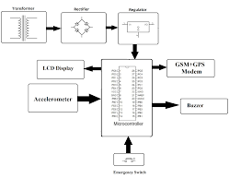

It consists of the following

1. The circuit consist of various sensors connected to the Arduino.

2. The analog output of pulse sensor, MQ-3 sensor and Accelerometer (MPU 6050) are

connected to the analog pins provided on the Aurdino.

3. The GSM module (SIM800L), vibration sensor (digital output) and H- Bridge (L293D) are

attached to the Arduino pins.

4. The H bridge is connected to the stepper motor.

5. The power (Vcc) is provided with 5V and the ground connections are made.

The applications of this system as

1. The system can be implemented in four wheelers and heavy automobiles with little

modifications to keep drunken drivers off the roads.

2. The GSM module will help communicate the accident to emergency services with the need of

a human to do so.

3. The system will detect and alert the driver when the vehicle is being driven rashly.

4. Undetected or unseen problems that may arise suddenly can be detected and care can be

provided immediately.

5. This can help avoid accidents that occur due to illness or other factors due which the driver

may lose concentration.

6. The system will keep the concerned people updated about the driver’s condition and his

location.

Fig.1.1 Animal or object detection

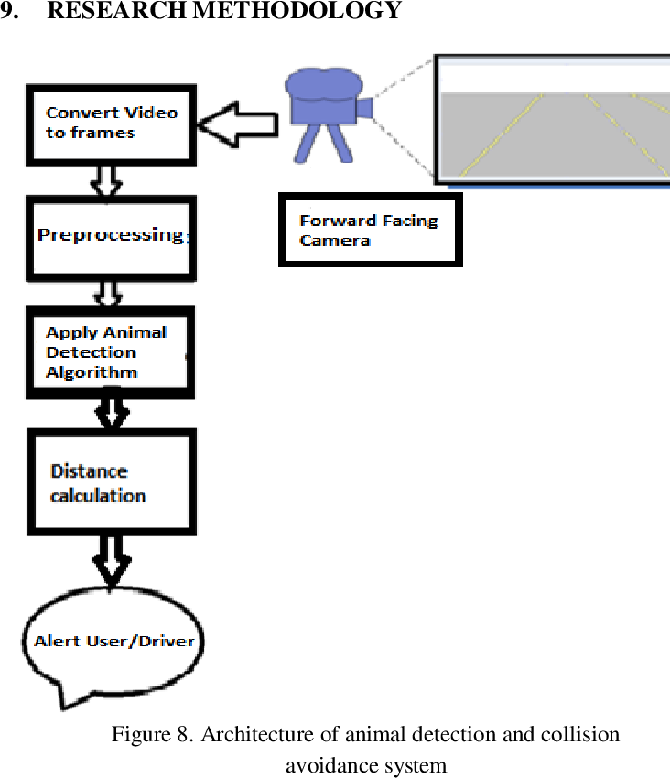 (b)

**PROPOSED METHOD**

The main idea of this paper is to build an application that makes use of the sensors present in

mobile phones like GPS and Accelerometer and detect any collision if there is a sudden

external disturbance in the speed with the help of the Sensor Fusion Based Algorithm. With

the help of the data obtained from the Accelerometer sensor, when there is a sudden

disturbance to the mobile phone, the user is notified with an alert message before sending the

request help signal. If no emergency is required, they can cancel it within 10 seconds. But, if

they press the “Call Help” button or if the alert message is unattended for more than 10

seconds, the "request for help" message will be sent to the emergency services as well as the

family members, the users provided

**SYSTEM ARCHITECTURE**

In this system, the external disturbance is detected by the accident detection module and

when it is detected, a function is called to find the current location of the user with the help of

GPS in the Location Detection Module. The location data obtained from the GPS is sent to

the emergency services to request help.

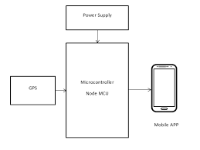

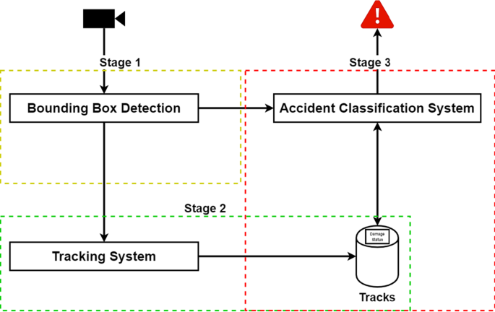

#### Vehicle unit sends the information to the emergency contacts like police control room and an ambulance unit.

In this system at first, we worked on the prevention of vehicle accident and even after all the preventive measures applied if the accident occurs the system detects it. After the detection of vehicle accident, the system automatically reports to the ambulance service and police station without any time loss so that the casualty might not loss his/her life due to lack of medical assistance in time. The system is installed in the vehicle.. For the detection of vehicle accidents accelerometers are installed and for reporting ,GPS module and GSM module are used. Motor (control switch) is used for engine control and buzzer, led lights etc. are used for warning during prevention. All these devices are interfaced with the central microcontroller (Arduino Uno) unit. Accelerometer detects the occurrence of accident and sends signal to the microcontroller for further functioning. The GPS module provides the location, speed, time and date of the certain place where the vehicle is in the real time. If an accident occurs, the accelerometer detects it and location of accident is obtained using GPS, and finally sends the information to the ambulance service and police by the help of a GSM module. The message obtained in mobile phone consists of the location of the accidental place in the form of google map link which will help the emergency units like ambulance service and police station to reach the casualty in time and rescue the lives.

1. The Arduino setup is installed in a vehicle's crash guard or in bumpers of the vehicle on each side.

2. When collision occurs it triggers the push button and it sends a notification to the Arduino Board.

3. Arduino will take this input and will convert to the SIM808. 4. The coordinates are shared through GSM.

5. Through GSM the notification is passed to the saved mobile number.

6. It contains the exact GPS location.

7. The application is used to know the route and location.

8. If the accident is not severe the person can turn off the buzzer and the device will come back to normal.

* 1. **Overview**

# Ultrasonic detection

Ultrasonic sensors work by emitting sound waves at a frequency too high for humans to hear. They then wait for the sound to be reflected back, calculating distance based on the time required. This is similar to how radar measures the time it takes a radio wave to return after hitting an object.

While some sensors use a separate sound emitter and receiver, it’s also possible to combine these into one package device, having an ultrasonic element alternate between emitting and receiving signals. This type of sensor can be manufactured in a smaller package than with separate elements, which is convenient for applications where size is at a premium.

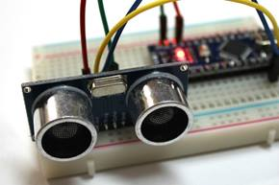

While radar and ultrasonic sensors can be used for some of the same purposes, sound-based sensors are readily available—they can be had for just a couple dollars in some cases—and in certain situations, they may detect objects more effectively than radar.

For instance, while radar, or even light-based sensors, have a difficult time correctly processing clear plastic, ultrasonic sensors have no problem with this. In fact, they’re unaffected by the color of the material they are sensing.

On the other hand, if an object is made out of a material that absorbs sound or is shaped in such a way that it reflects the sound waves away from the receiver, readings will be unreliable.

**Obstacle Sensing System**

The sensor has four pins that is VCC, ground, echo and trigger pulse. VCC and ground are connected to the respectivep ins in the microcontroller. The trigger pule: is connected to pinl of PORT D while the echo pin is connected to pin 3 of PORT D. The operation of the sensing unit is as follows

* Send a short, but long enough Eus pulse on the trigger pin (module automatically sends eight 40KHz square wave):
* Wait for the echo line 10 go high:
* Time the length of the pulse that stays high.
* The length of the pulse is directly proportional to distance. The range is being
* calculated using the following formula:
* Distance incentimeters = us/58

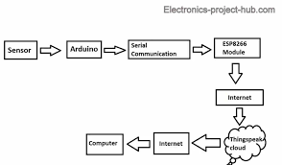

**Warning or Alerting system**

The device can be connected along with LED’S and Buzzer to alert the user when the collision is about to happen.

As the main purpose of this device would be sending sos signals is the Collision is of higher frequency. Detection of any obstacle in front of the vehicle or the object is the initial step, and it is carried out by the ultrasonic sensor. The ultrasonic sensor is customized to have a specific range for detection. With the help of this variety in ranges multiple messages can be can be created and allotted to the particular scenario.

* For far of range , the devices sends a Alert message stating “Object close stay alert”
* For close range , the object alerts with the help of buzzer’s high pitched tone.
* For the impact, the device carries out multiple procedure:

1. It send an SOS message to the vehicles owner.
2. With GSM extension it can also deliver the message via sms.
3. With ESP32 we can customize the device to even generate and send a graph that represents the impact intensity. If the intensity is high it also informs nearby hospitals for the collision.
4. It can also inform near by fire stations if the collision leads to formation of flames.

This project allows us to create a wide number of applications which can help the individual to reach the hospital or even inform the fire stations on time .

It also creates wide scope for improvements and modification with updated and even more components.

For example:

* Pressure Sensor: Can be used to determine the impact intensity
* Smoke Sensor: Can be use to detect smoke after the collision
* Motion Sensor : Can be used as a substitute for Ultrasonic sensors

.

* Optical Sensors : Can be used to provide images for intensity detection.

In this project , The alerting provide is carried out with the help of ESP32 Wifi module which allows us to send the message to any chosen application. In this presentation we have used Telegram as the application.

**SOURCE CODE**

**#include <WiFi.h>**

**#include <WiFiClientSecure.h>**

**#include <UniversalTelegramBot.h>**

**// Wifi network station credentials**

**#define WIFI_SSID "Rohit's iPhone"**

**#define WIFI_PASSWORD "rohit2929"**

**// Telegram BOT Token (Get from Botfather)**

**#define BOT_TOKEN "6091295695:AAHPRljyVo5TTPnEza_i-ngI3ghXDCfNMCw"**

**const int trigPin = 26;**

**const int echoPin = 27;**

**//define sound speed in cm/uS**

**#define SOUND_SPEED 0.034**

**#define CM_TO_INCH 0.393701**

**long duration;**

**float distanceCm;**

**float distanceInch;**

**const unsigned long BOT_MTBS = 1000; // mean time between scan messages**

**int f=0;**

**WiFiClientSecure secured_client;**

**UniversalTelegramBot bot(BOT_TOKEN, secured_client);**

**unsigned long bot_lasttime; // last time messages' scan has been done**

**bool Start = false;**

**#define chat_id "1579937853"**

**void setup() {**

**Serial.begin(115200);**

**Serial.println();**

**// attempt to connect to Wifi network:**

**Serial.print("Connecting to Wifi SSID ");**

**Serial.print(WIFI_SSID);**

**WiFi.begin(WIFI_SSID, WIFI_PASSWORD);**

**secured_client.setCACert(TELEGRAM_CERTIFICATE_ROOT);**

**// Add root certificate for api.telegram.org**

**while (WiFi.status() != WL_CONNECTED)**

**{**

**Serial.print(".");**

**delay(500);**

**}**

**Serial.print("\nWiFi connected. IP address: ");**

**Serial.println(WiFi.localIP());**

**Serial.print("Retrieving time: ");**

**configTime(0, 0, "pool.ntp.org"); // get UTC time via NTP**

**time_t now = time(nullptr);**

**while (now < 24 * 3600)**

**{**

**Serial.print(".");**

**delay(100);**

**now = time(nullptr);**

**}**

**Serial.println(now);**

**pinMode(trigPin, OUTPUT); // Sets the trigPin as an Output**

**pinMode(echoPin, INPUT); // Sets the echoPin as an Input**

**}**

**void loop() {**

**// Clears the trigPin**

**digitalWrite(trigPin, LOW);**

**delayMicroseconds(2);**

**// Sets the trigPin on HIGH state for 10 micro seconds**

**digitalWrite(trigPin, HIGH);**

**delayMicroseconds(10);**

**digitalWrite(trigPin, LOW);**

**// Reads the echoPin, returns the sound wave travel time in microseconds**

**duration = pulseIn(echoPin, HIGH);**

**// Calculate the distance**

**distanceCm = duration * SOUND_SPEED/2;**

**// Convert to inches**

**distanceInch = distanceCm * CM_TO_INCH;**

**// Prints the distance in the Serial Monitor**

**Serial.print("Distance (cm): ");**

**Serial.println(distanceCm);**

**Serial.print("Distance (inch): ");**

**Serial.println(distanceInch);**

**if (millis() - bot_lasttime > BOT_MTBS)**

**{**

**if((distanceCm<5)&&(f!=2))**

**{**

**f=2;**

**bot.sendMessage(chat_id, "Collision detected...!!!\nSOS...");**

**}**

**else if((distanceCm<15)&&(f!=1))**

**{**

**f=1;**

**bot.sendMessage(chat_id, "Vehicle too Close..!\nBe Aware.");**

**}**

**else**

**{**

**f=0;**

**}**

**bot_lasttime = millis();**

**}**

**//  delay(1000);**

**}**

COMPONENTS USED IN THE PROJECT:-

1. ESP 32:-

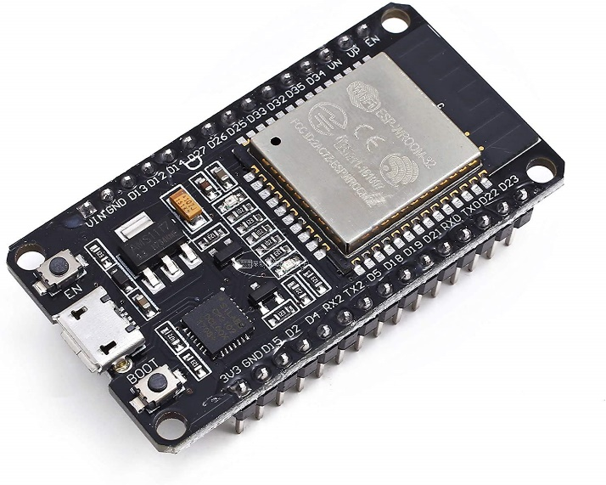

The ESP32 family of system on a chip microcontrollers features integrated Wi-Fi and dual-mode Bluetooth and is inexpensive and low power. The Tensilica Xtensa LX6 dual-core or single-core microprocessor, Tensilica Xtensa LX7 dual-core, or a single-core RISC-V microprocessor are used in the ESP32 series, which also has integrated antenna switches, RF baluns, power amplifiers, low-noise receive amplifiers, filters, and power-management modules. Chinese business Espressif Systems, with headquarters in Shanghai, invented and constructed the ESP32, which is produced by TSMC using their 40 nm technology.It is the ESP8266 microcontroller's replacement.

Espressif Systems, the same company that created the well-known ESP8266 SoC, offers the inexpensive ESP32 System on Chip (SoC) Microcontroller. The 32-bit Xtensa LX6 Microprocessor by Tensilica is a replacement for the ESP8266 SoC and features built-in Wi-Fi and Bluetooth. It is available in single-core and dual-core versions.

The advantage of ESP32 is that it has inbuilt RF components such a power amplifier, a low-noise receiver amplifier, an antenna switch, filters, and an RF balun, similar to ESP8266. As a result, it is very simple to construct hardware around the ESP32 since minimal external components are needed.

The fact that ESP32 is produced utilising TSMC's ultra-low-power 40 nm technology is another crucial information to be aware of. Therefore, employing ESP32 should make it very simple to create battery-powered applications like as wearables, audio equipment, baby monitors, smart watches, etc.

1. ULTRA SONIC SENSOR:-

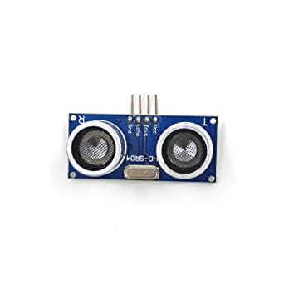

An ultrasonic sensor is a piece of technology that uses ultrasonic sound waves to measure a target object's distance and then turns the sound that is reflected back into an electrical signal. Ultrasonic waves move more quickly than audible sound—the kind of sound that people can hear—does. The transmitter, which uses piezoelectric crystals to produce the sound, and the receiver, which encounters the sound after it has gone to and from the target, are the two primary parts of an ultrasonic sensor.

Ultrasonic sensors are electronic devices that use the emission of ultrasonic sound waves to determine a target's distance before converting those waves into electrical signals. The speed of travelling ultrasonic waves is greater than the speed of audible sound.

1. BREAD BOARD:-

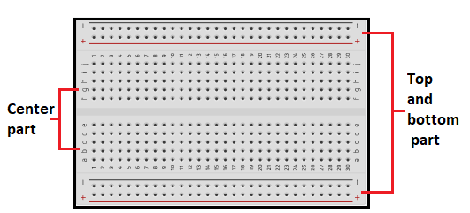

Electronic circuits can be temporarily assembled on breadboards. Solid wire, not stranded, 24-gauge wire is used to connect circuits and is compatible with the majority of breadboards. There are occasionally kits available with different colours of set lengths that are designed specifically to fit breadboards. A nice convenience, these.

Figure 10.6a shows a breadboard (plugboard) with sets of tiny sockets arranged in a 0.1-inch grid that may manually accommodate component leads and tinned copper wire (TCW) linkages. There are several contacts on each IC pin thanks to rows of contacts connected in groups and positioned on either side of the board's centre line, where the ICs are installed. There are three on either side of the board.

1. CONNECTING WIRES:-

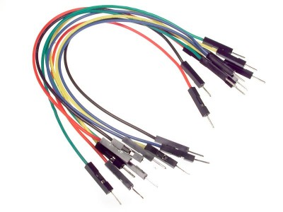

A circuit's conducting wire, which carries the circuit's current, is one of its components. It is constructed using a material that conducts current, such as copper or tungsten.

An insulating substance, such as rubber, is placed over the wire for protection and to prevent current loss.

In a circuit, conducting wires are represented by various colors to indicate their purpose. Grounding wires are colour green, neutral wires are colour black, and live wires are often colour red.

**APPLICATIONS OF COLLISION DETECTOR SYSTEM**:-

1. USED IN AIRCRAFTS:-

The probability of mid-air collisions or near mid-air collisions between aircraft was decreased with the introduction of the Airborne Collision Avoidance System II (ACAS II). In spite of any separation requirements, it acts as a last resort safety net.

ACAS II is a transponder-based aircraft system for Secondary Surveillance Radar (SSR). ACAS II queries the Mode C and Mode S transponders of surrounding aircraft (referred to as "intruders") and, using the responses, determines their altitude and range and, as necessary, sends alerts to the pilots. ACAS II will not detect aircraft without transponders and will not provide any resolution recommendations for traffic lacking altitude reporting transponders.

ACAS II operates independently of the ground-based Air Traffic Control (ATC) systems, flight management systems, and aircraft navigation systems. When evaluating threats, it

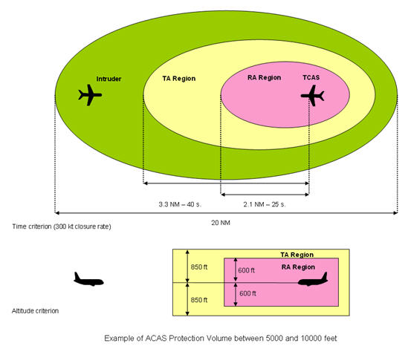

1. USED IN AUTOMOBILE:-

By identifying stationary or slowly moving cars in front of your car, forward collision warning systems alert you to the possibility of an impending collision. While you are driving, forward collision warning uses radar, lasers, or cameras to monitor the road ahead. The technology will alert you to the danger if there is an oncoming collision utilising lights, beeps, seat vibrations, or a combination of these. Additionally, certain systems might tighten your seatbelt and pre-charge your brakes to help you stop as swiftly as possible.

Forward collision warning systems are rapidly being included into a large number of automobiles, along with other safety features like automated emergency braking. If your car has automatic emergency braking, it will apply the brakes quickly if you don't.

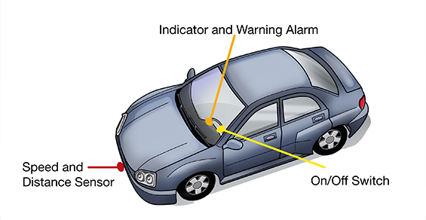

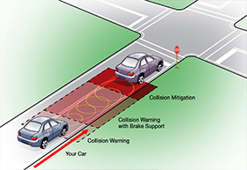

1. USED IN INDUSTRY:-

What is the process of a collision avoidance system? An efficient tracking system, which can keep track of employees' and equipment's whereabouts to make sure they don't cross paths, is the cornerstone of most collision avoidance strategies.

To ensure a human operator can observe the relative positions of everything within a mine, whether a surface or underground operation, this can take the form of tags that are worn by employees and linked to equipment and vehicles.

In order to prevent collisions from happening, these collision avoidance systems additionally have alarms and notifications that sound when two tags are moved too closely together.

Additionally, these collision detection features are adaptable, allowing

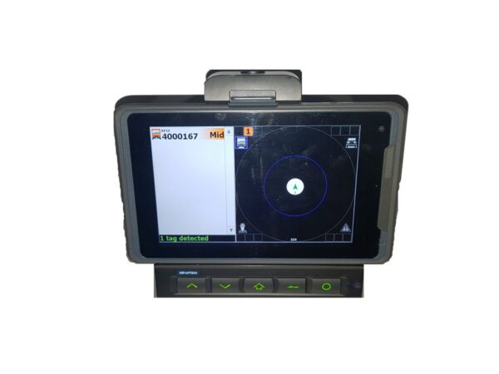

ADVANTAGES OF COLLISION DETECTOR SYSTEM:-

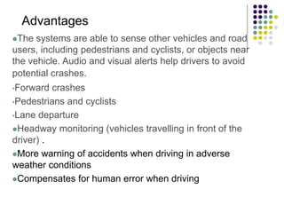

## CONCLUSION

In conclusion, the collision detection system project is a significant and cutting-edge technological advancement that has the potential to save lives and avoid accidents. The system can detect the existence and closeness of objects and cars and warn drivers of potential hazards by using sensors, cameras, and software algorithms.

In the modern world, where distracted driving and traffic congestion are key causes of traffic accidents, this project is especially pertinent. Drivers can be alerted to potentially hazardous conditions and take appropriate action to avoid crashes by adopting a collision detection system.

Even if there are still some difficulties to be solved in terms of accuracy and dependability, the collision detection system project has a lot of potential and could end up being a common feature in upcoming cars. keeping going.

## REFERENCES

* Hang, P., Han, Y., Chen, X., & Zhang, B. (2018). Design of an active collision
* avoidance system for 4WIS-4WID electric vehicle. IFAC PapersOnLine, Vol. 51, Issue 31,
* 771-777.
* Joukhadar, A., Issa, H., & Kalaji, Y. (2018). Design and implementation of auto car
* driving system with collision avoidance. Cogent Engineering, Vol. 5, Issue 1, 1-16.
* Megha, G., & Srivani, P. (2016). Collision avoidance in vehicles. International Journal
* of Advances in Electronics and Computer Science, Special Issue, 139-140.
* Nyamati, V., Chaudhuri, T., & Jayavel, K. (2017). Intelligent collision avoidance and
* safety warning system for car driving. International Conference on Intelligent Computing and
* Control Systems (IEEE), India, 791-796.
* Sanjana, T., Wahid, F., Habib, M., & Rumel, A. (2018). Design of an automatic forward
* and back collision avoidance system for automobiles. Advances in Science, Technology and

Engineering Systems Journal, Vol.3, No.1, 205-212.